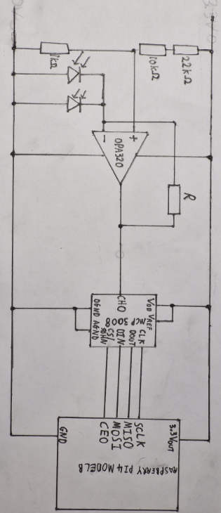
The program written allows the Pi to read the digital value input into it.
This is the MCP 3008 ADC. The input analogue voltage signal is converted into a 10-bit digital value, taking any value between 0 and 1023, and this value is then input into the Pi, allowing the Pi to process the light intensity information from outside.
V_{OUT}
These are the photodiodes. I have used 2 in parallel rather than just one, as I discovered that using more photodiodes in series increases the ‘sensitivity’, or gain, of the amplifier, meaning that the amplifier saturates earlier.
This is a potential divider. Using resistors in series, I have produced a constant input voltage, which is V_{OUTMIN} , into the OPA320.
This is the circuit diagram for the input section of the circuit diagram. To summarise, the photodiodes consume light energy and produce current from it. The OPA320 designed as a transimpedance amplifier then converts this into an analogue voltage signal. This is input into the MCP 3008 ADC, which converts the input signal into a 10-bit ADC value, which is then input into the Pi via various connections.
This is a potentiometer. I have labelled it as ‘R’ rather than with a constant resistor value as the resistance is variable and can be changed during testing and for final changes.
The Raspberry Pi acts as a power supply for the input part of the circuit. I use the 3.3V output pin as the positive power rail, and the GND pin as the 0V power rail.

